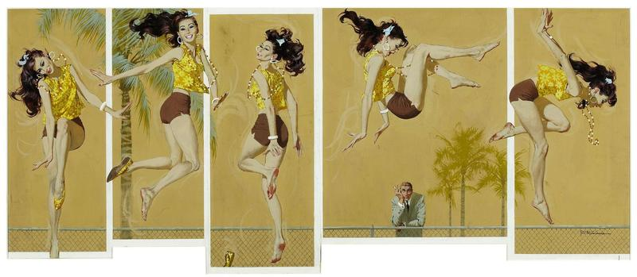

**The Artist**

I picked Robert E Mcginnis for the artist section, he illustrated this for a short story for the post called the *Kitten on a trampoline.* Instead of painting one cover like he usually did for these short stories, he went for multiple frames portraying various poses and create a stop-motion photography feel to it. The short story is of a man getting enthralled by a woman on a trampoline as he was going about his mundane life.

The image itself does such great job portraying the subject of the story that I felt like I was the protagonist in the background staring at someone enjoying themselves jumping around on a trampoline. It evokes a carefree life and possibly happiness that the protagonist and us as the readers might be missing from our lives.



**The Designer**

Picked Chip Kidd as the designer, he has been in almost all the book I own.

This book cover he designed for author Sam Michel. This is a book of short stories. It’s a great cover design showing tiny image of a man under a spotlight. This goes design not only compliments the title of the book, but also the theme of short stories within it.

Not sure what problems the designer might actually be trying to solve here, but I think it solves the issue of having just a title and no correlating image like most book covers do. This peaks a potential readers image and lets them judge the book by it’s cover…if they want to.